- The title Management Review Detail should be Risk Management Review Detail in the executive report sections and in pdf and ppt. This change should prove that we change it in one point and it changes everywhere: One single point of truth.
I just saw it is not, because in the index we have this title but it is not the title of the section inside of the report.
In the screen the index is not exactly the same as in the reports.
Gantt detail does not appear in the index.
Please recheck all the index and section titles to be recovered from a single point of truth in multilingual.
I think Executive Risk attention is a better title than Risk attention. Multilingual alignment is needed. This already appears on the screen and not in the reports.

In pdf some cockpits are weird.
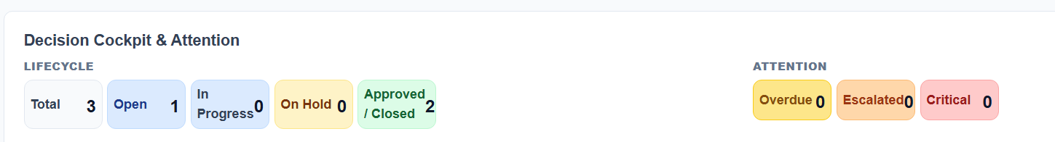
Good

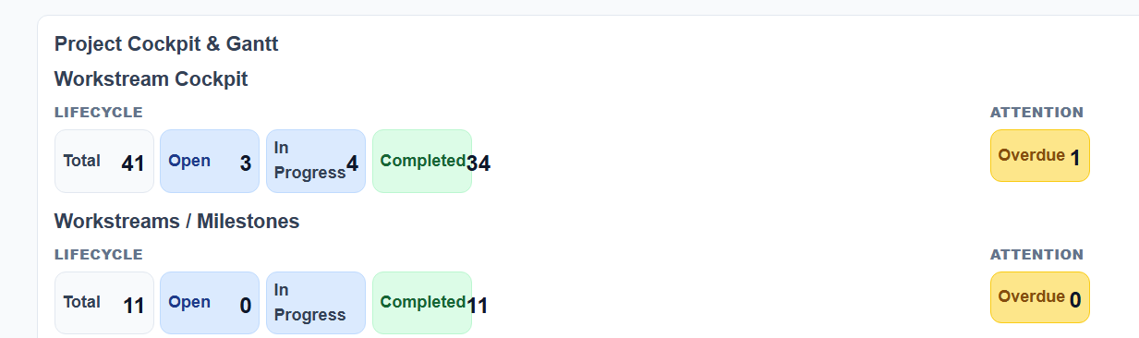
The number of completed is outside the box.

In ppt it looks good but the font is smaller.
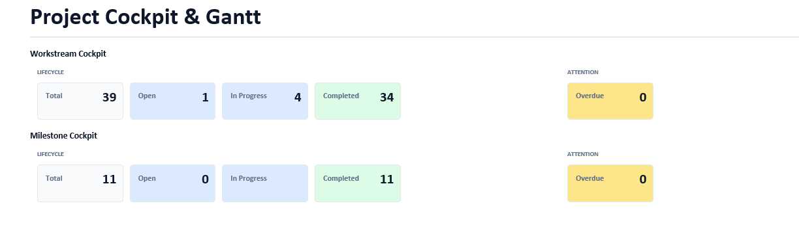
The font should be standard in both report types. Has this been standardized? Is there a single point of truth?

Title is missing in ppt for Executive Risk attention

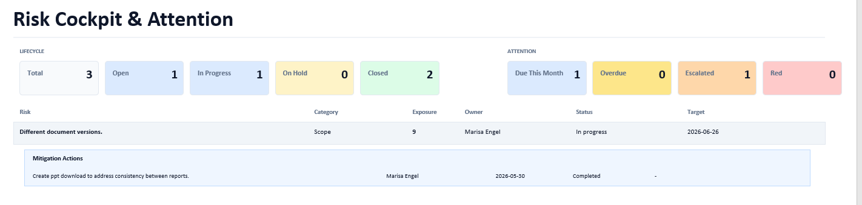

It is on the screen

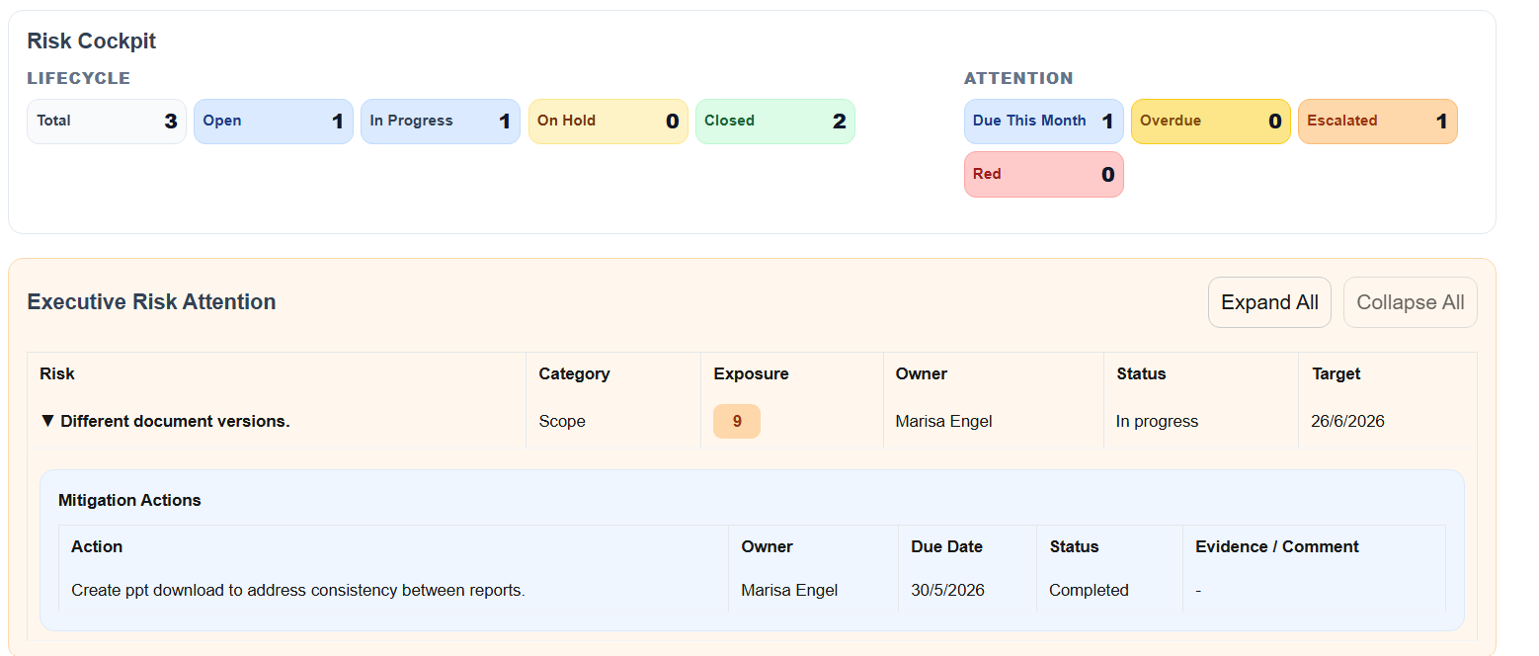

I think it comes from that you obviously do not want to show the buttons on the reports so the whole line is omitted.

Please review it across the whole executive report.

The weird thing it appears ok in pdf. Again we do not have a single point of truth.
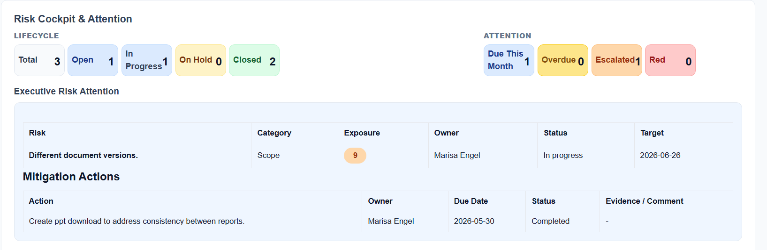
- As we have to standardize title and I do not like attention, please change Risk attention to Escalated Risks and Decision Attention to Decision Queue.
- The organization description is not translated to Spanish.
- The Risk section is the only section that does not have a description of what is included.
- Remove the project number and also the logo field from the title page of pdf and ppt documents.
- I will continue testing when everything is aligned and hardened.

